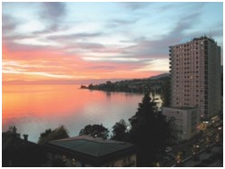

The Hotel
Situated on the lakeside on the edge of Geneva Lake, the hotel enjoys a peaceful and particularly sunny position. It offers 152 rooms, most of them with a balcony and sitting area, with wonderful lake and mountain views. All rooms are air-conditioned. Breakfast, Internet, and free transportation in the area are included.

The room rate per day is:
- 198 CHF for a single use room with lake view
- 218 CHF for a double use room with lake view
- Breakfast included
- 4 CHF tax per person per day not included

These special prices are available from July 18th to July 23nd 2018.

Registration
Registration for the hotel stay is to be made directly with the Hotel
EUROTEL RIVIERA MONTREUX

Phone: +41 21 966 22 22
Fax: +41 21 966 22 20

E-Mail: eurotelriviera@euriv.ch
Website: www.eurotel-montreux.ch

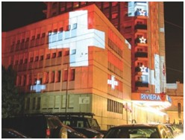
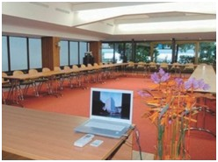

Registrations for the Summer Seminars are to be made by mailing, emailing or faxing the registration form to the Office Manager of the ISR:
Sushila Dixit.
E-mail: sushila.dixit@hogrefe.ch
Fax: (+41) 31 300 45 90

The registration form with contact information is available on the website of the ISR: www.rorschach.com

Latest registration date for the
Summer Seminars is May 15th,
2018.

Registration fee
Before April 15th, 2018:
- 540 CHF for ISR members
- 570 CHF for non-members
After April 15th, 2018:
- 570 CHF for ISR-members
- 600 CHF for non-members
- 25 CHF for CE credits

The registration fee includes: Summer Seminars conference fee, three lunches, water, coffee and coffee breaks in the morning and afternoon.

Dinner evening (optional)

Montreux Jazz Café at the Fairmont. Walking distance from the Eurotel.

Please note that hotel and conference registrations are separate. Use the registration form on the website only for the Summer Seminars registration. Also note that the number of participants is limited, in order to maintain a more intimate format. Registrations are dealt with in order of arrival.
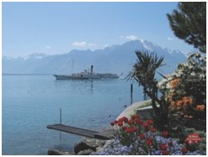

How to get to Montreux

By air and train
There are airports in Geneva, Zurich and Basel-Mulhouse. Getting from these airports to the Swiss Riviera by train is very easy and comfortable.
- From Geneva: Every hour there is a train from Geneva to Montreux. The trip takes about 1 hour.
- From Zurich: Every 30 minutes there is a train from Zurich to Montreux (via Bern/Lausanne). It takes about 2½ hours.
- From Basel-Mulhouse: Every hour there is a train from Basel- Mulhouse to Montreux (via Bern/Lausanne). It takes about
2½ to 3 hours.

By car
Approaching from the north, east and west, motorways provide easy access to Montreux.

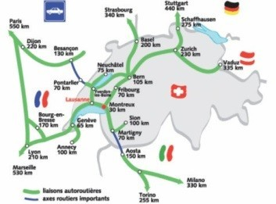

The Summer Seminars of the International Society of the Rorschach and Projective Methods
Montreux, Switzerland,
July 20th – July 22nd 2018

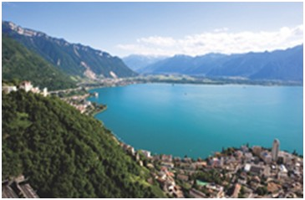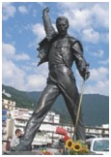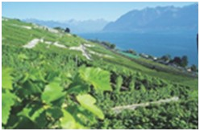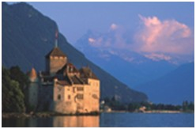

The sheltered Lake Geneva bay is surrounded by vineyards, and is set against the breathtaking backdrop of snow-covered Alps. The very famous Montreux Jazz Festival, which takes place in June/July, features concerts on a variety of stages and parks.

Because of its exceptionally mild climate, Montreux is called the capital of the Vaud Riviera. Plants associated with the Mediterranean region, such as pines, cypresses and palm trees grow here. Charlie Chaplin, Freddie Mercury and several other famous people of world-renown lived and continue to live on the Vaud Riviera.

The long, flower-bordered lake promenade which links Vevey and Montreux, going all the way up to Chillon Castle, begs for a leisurely stroll. Cultural events, such as the Montreux Jazz Festival, as well as countless excursion options to the mountainous hinterland or on the lake itself make Montreux a most popular excursion and holiday destination. Many of the houses along the lakeside road, including the magnificent Fairmont Le Montreux Palace, date from the heyday of the Belle Époque. The town also boasts a modern congress and exhibition centre: the Montreux Music and Convention Centre.

The lake is ideal for bathing, water sports or a cruise. And along the lake promenade, piano and jazz bars, discos and Switzerland's oldest casino mingle with hotels and restaurants.
History Revived
The International Society of the Rorschach and Projective Methods has renewed the tradition of this form of continuing education, which is held every year in bet- ween congresses. Welcome to the 12th edition of the Summer Seminars!

Recent Times
Today, we are pleased to welcome members from all over the world and with different languages. We have found English to be a language common enough for us all to present the lectures only in English. There will, however, be colleagues who can translate on a more informal basis into other major languages when needed, during the lectures/workshops in order to facilitate dialogue.

We usually have 30-40 participants (maximum) plus the faculty. The small format gives everybody a chance to take active part in the discussions and to get to know each other. We are offering lectures, work- shops on case studies and lots of informal discussions around different matters around the dinner tables and in the garden. Since we all have our meals together and stay at the same hotel, the chance of making new friends is obvious.

About our theme
When the Body Speaks: Somatic Issues and Projective Methods
By F. Barton Evans
Somatic issues and somatization have become an increasingly important focus for modern psychodynamic and other comprehensive neuroscience based personality models in understanding expression of unprocessed experiences of anxiety and depression into bodily manifestations. Somatic communications of inner conflict, psychological trauma, and physical endangerment often escape the individual’s capacity to mentalize and speak his inner experience but deeply troubled clients find such a voice through the Rorschach Inkblot Method. This year’s Summer Seminars explore how the RIM and other projective techniques aid in a careful assessment of somatic issues and somatization and can provide a voice for clients’ soma-psychic suffering.

The Faculty
We are proud to present the invited Faculty and the topics they will cover at this 12th Summer Seminars:

F. Barton Evans, Ph.D, Asheville, NC., USA. Clinical and forensic psychologist in private practice and Clinical Professor of Psychiatry and Behavioral Science, East Tennessee State University College of Medicine. He has published 4 books and numerous book chapters and papers on the Rorschach and other personality assessment in psychological trauma.
Title:The case of a young woman with chronic debilitating physical complaints of unclear medical origin”.
Dr. Evans’s presentation will focus on the embodiment of psychological trauma as it presents on the Rorschach. He will begin with a review of psychological literature on the Rorschach and psychological trauma. He will then present a Therapeutic Assessment case of a 20-year-old woman with plaguing, though indistinct, physical and psychological symptoms. Dr. Evans will show how the Rorschach assisted this young woman to “find her voice” to describe previously inchoate and “locked in” inner suffering.

Tevfika Ikiz, Istanbul, Turkey.
Professor at Istanbul University, Department of Psychology, Psychoanalyst, Founder and President of the Turkish Society for Rorschach and Projective Tests. Working with psychosomatic patients and member of IPSO (Paris Psychosomatic School).
Title: “The sick body in adolescence: obesity and family relations”
In obese families, food and its consumption aim to fill internal gaps and avoid the existential emptiness of family members. The parents’ anxiety and inability to contain the affective states of their children seem to relate to conflicts around narcissism, orality, emptiness and separation. The morning session will focus on difficulties in coping with this disorder, as well as their multifactor etiologies). In the afternoon session, the case of an adolescent will be presented: Rorschach and TAT, as well as other projectivetests taken by the whole family.

Sylvie Gosselin, M.Ps., Quebec City, Canada. Psychologist in a Chronic Pain Center, mainly with adult and elderly patients. Evaluation, psycho-therapy and multi-disciplinary work with anesthesiologists, physiotherapists, pharmacists and occupational therapists.
Title: “The contribution of projective methods to the multidisciplinary treatment of chronic pain”
Psychic issues and somatization are frequently ignored in the treatment of patients who suffer from chronic pain and their impact tend to be misunderstood. The contribution of projective techniques in the treatment of those patients will be demonstrated with different case studies and theoretical concepts. The case of a woman with an interstitial cystitis will be analyzed in the afternoon session, to show how a better comprehension of her personality organization led to a drastic rethinking of her treatment.. Discussants: Bruce Smith, Ph.D and F. Barton Evans, Ph.D

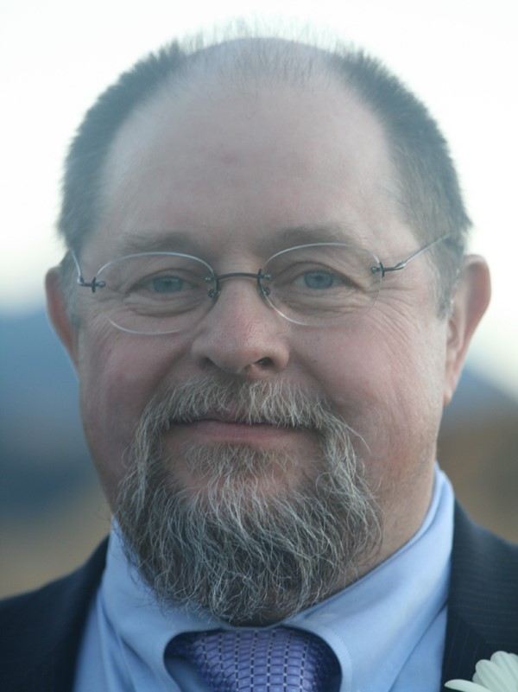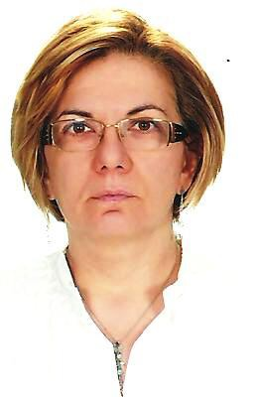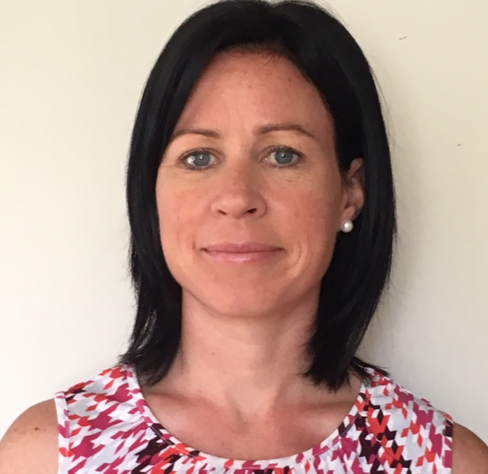

F. Barton Evans Tevfika Ikiz Sylvie Gosselin

Our Faculty will provide the case material, which will be available to you before the Seminars. As usual, we expect different schools and traditions to be represented among our participants. This diversity promotes interesting discussions and dialogues.

ISR Continuing Education: Odile Husain at odilehz@hotmail.com

Summer Seminars Program
The Summer Seminars run for 3 days, from 20th to 22nd July 2018. Mornings are dedicated to lectures and theoretical presentations. The case material will be presented in the afternoon, after our lunch break. The case material is first analyzed in smaller groups of participants, then commented in roundtable discussions between Faculty and all participants. Participants have the opportunity to interact directly with the Faculty. Our participants appreciate both formats of discussion.

Daily schedule:
Morning session: 9 am to 12 pm
Lunch period: 12 pm to 2 pm
Afternoon session:
Small group discussion: 2 pm to 4 pm
Large group roundtable discussion: 4 pm to 5.30 pm

New at the Summer Seminars: CE credits!
For an additional fee of 25.00 CHF, 20 hours of CE credits will be available. Request must be made at the time of registration.

Dinner Evening
21st July 2018 at 7 pm
Restaurant : Montreux Jazz Café at the Fairmont
Cost per person: 75.00 CHF
This includes a set menu with an entrée, a main dish, a dessert and coffee or tea.
Drinks à la carte or beverage package (3 dcl of regional wine and unlimited mineral water) for 28.00 CHF.

Since the program is being set so much ahead of the event, slight changes may occur. We will, in any event, try to make it an enjoyable and interesting opportunity for sharing the knowledge of researchers and clinicians from different schools and traditions who hold a vast experience of the Rorschach. This is also an opportunity to make new friends and meet with colleagues from all over the world.

The Summer Seminars are taking place at the EUROTEL RIVIERA MONTREUX. All participants are expected to register separately for their stay.

Please note that the maximum number of participants at the Seminars is 40. First come, first serve!

Important: Please note that the hotel registration has to be done directly with the hotel. www.eurotel-montreux.ch

